Practical 8

NAME: TASNEEM SADIKOT
PRN: 23070521162

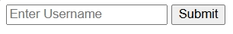
<!DOCTYPE html>
<html>
<body>
<form onsubmit="return validate()">
<input type="text" id="username" placeholder="Enter Username" required>
<button type="submit">Submit</button>
</form>
<script>
function validate() {
let username = document.getElementById("username").value.trim();
if (username === "") {
alert("Username is required");
return false;
}
alert("Valid!");
return true;
}
</script>
</body>
</html>

<!DOCTYPE html>
<html>
<body>
<form onsubmit="return validate()">
<input type="text" id="age" placeholder="Enter your age">
<button type="submit">Submit</button>
</form>

<script>
function validate() {
let age = document.getElementById("age").value;
if (isNaN(age)) {
alert("Age must be a number");
return false;
}
alert("Valid number!");
return true;
}
</script>
</body>
</html>

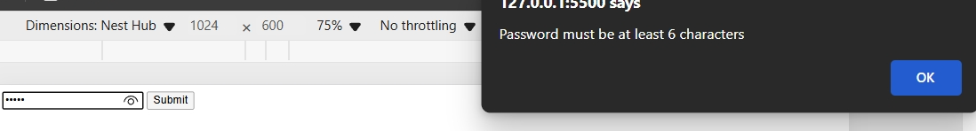
<!DOCTYPE html>
<html>
<body>
<form onsubmit="return validate()">
<input type="password" id="password" placeholder="Enter password">
<button type="submit">Submit</button>
</form>
<script>
function validate() {
let password = document.getElementById("password").value;
if (password.length < 6) {
alert("Password must be at least 6 characters");
return false;
}
alert("Password length OK!");
return true;
}
</script>
</body>
</html>

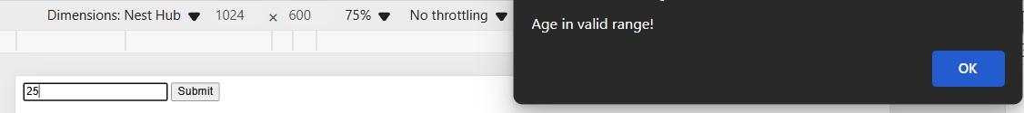
<!DOCTYPE html>
<html>
<body>
<form onsubmit="return validate()">
<input type="number" id="age" placeholder="Enter your age" required>
<button type="submit">Submit</button>
</form>
<script>
function validate() {
let age = parseInt(document.getElementById("age").value);
if (age < 18 || age > 60) {
alert("Age must be between 18 and 60");
return false;
}
alert("Age in valid range!");
return true;
}
</script>
</body>
</html>

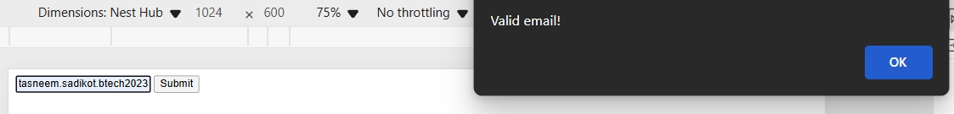
<!DOCTYPE html>
<html>
<body>
<form onsubmit="return validate()">
<input type="text" id="email" placeholder="Enter your email" required>
<button type="submit">Submit</button>
</form>
<script>
function validate() {
let email = document.getElementById("email").value;
let pattern = /^[^ ]+@[^ ]+\.[a-z]{2,3}$/;
if (!email.match(pattern)) {
alert("Invalid email format");
return false;
}
alert("Valid email!");
return true;
}
</script>
</body>
</html>

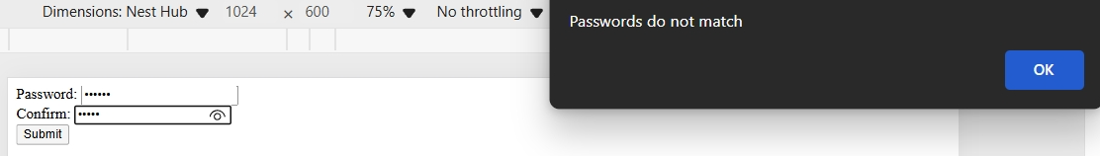
<!DOCTYPE html>
<html>
<body>
<form onsubmit="return validate()">
Password: <input type="password" id="p1"><br>
Confirm: <input type="password" id="p2"><br>
<button type="submit">Submit</button>
</form>

<script>
function validate() {
let p1 = document.getElementById("p1").value;
let p2 = document.getElementById("p2").value;
if (p1 !== p2) {
alert("Passwords do not match");
return false;
}
alert("Passwords match!");
return true;
}
</script>
</body>
</html>

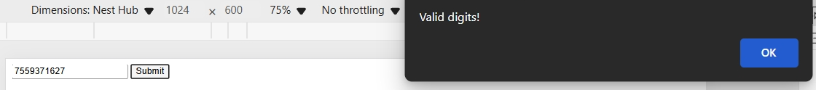
<!DOCTYPE html>
<html>
<body>
<form onsubmit="return validate()">
<input type="text" id="phone" placeholder="Enter phone number" required>
<button type="submit">Submit</button>
</form>

<script>
function validate() {
let phone = document.getElementById("phone").value;
if (!/^[0-9]+$/.test(phone)) {
alert("Phone must contain only digits");
return false;
}
alert("Valid digits!");
return true;
}
</script>
</body>
</html>

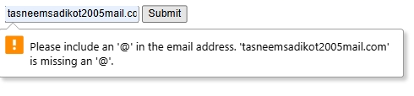
<!DOCTYPE html>
<html>
<body>
<form>
<input type="email" placeholder="Enter your email" required>
<button>Submit</button>
</form>
<script>
let pattern = /^[^ ]+@[^ ]+\.[a-z]{2,3}$/;
if (!email.match(pattern)) {
alert("Invalid email address");
}
</script>
</body>
</html>

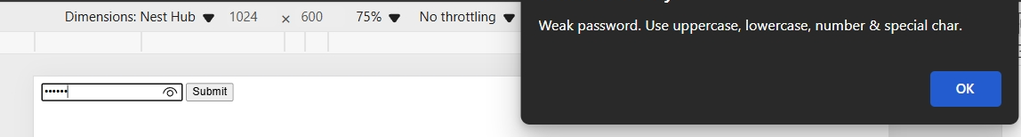
<!DOCTYPE html>
<html>
<body>
<form onsubmit="return validate()">
<input type="password" id="pass" placeholder="Enter password" required>
<button type="submit">Submit</button>
</form>
<script>
function validate() {
let pass = document.getElementById("pass").value;
let strong = /^(?=.*[A-Z])(?=.*[a-z])(?=.*[0-9])(?=.*[@#$%^&+=]).{8,}$/;
if (!pass.match(strong)) {
alert("Weak password. Use uppercase, lowercase, number & special char.");
return false;
}
alert("Strong password!");
return true;
}
</script>
</body>
</html>

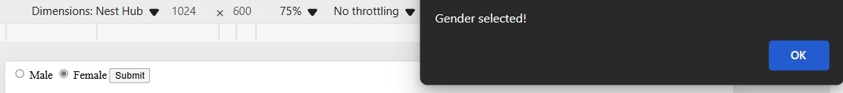
<!DOCTYPE html>
<html>
<body>
<form onsubmit="return validate()">
<input type="radio" name="gender" value="male"> Male
<input type="radio" name="gender" value="female"> Female
<button type="submit">Submit</button>
</form>

<script>
function validate() {
let selected = document.querySelector('input[name="gender"]:checked');
if (!selected) {
alert("Please select your gender");
return false;
}
alert("Gender selected!");
return true;
}
</script>
</body>
</html>

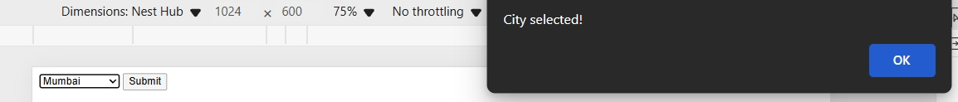
<!DOCTYPE html>
<html>
<body>
<form onsubmit="return validate()">
<select id="city">
<option value="">--Select City--</option>
<option value="mumbai">Mumbai</option>
<option value="delhi">Delhi</option>
</select>
<button type="submit">Submit</button>
</form>
<script>
function validate() {
let city = document.getElementById("city").value;
if (city === "") {
alert("Please select a city");
return false;
}
alert("City selected!");
return true;
}
</script>
</body>
</html>

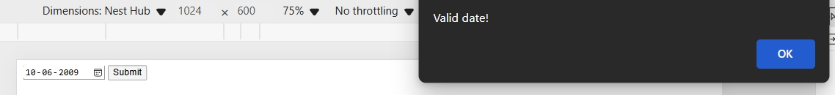
<!DOCTYPE html>
<html>
<body>
<form onsubmit="return validate()">
<input type="date" id="dob">
<button type="submit">Submit</button>
</form>
<script>
function validate() {
let dob = new Date(document.getElementById("dob").value);
let today = new Date();
if (dob > today) {
alert("Date of Birth cannot be in the future");
return false;
}
alert("Valid date!");
return true;
}
</script>
</body>
</html>

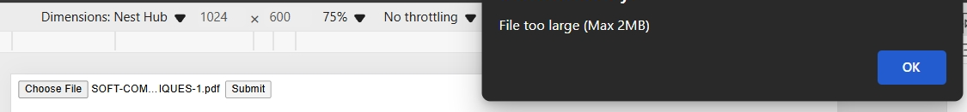
<!DOCTYPE html>
<html>
<body>
<form onsubmit="return validate()">
<input type="file" id="resume">
<button type="submit">Submit</button>
</form>

<script>
function validate() {
let file = document.getElementById("resume").files[0];
if (!file) {
alert("Please upload a file");
return false;
}
if (file.size > 2 * 1024 * 1024) {
alert("File too large (Max 2MB)");
return false;
}
if (!file.name.endsWith(".pdf")) {
alert("Only PDF allowed");
return false;
}
alert("Valid file!");
return true;
}
</script>
</body>
</html>
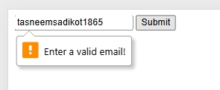
<!DOCTYPE html>
<html>
<body>
<form>
<input type="email" required oninvalid="this.setCustomValidity('Enter a valid email!')">
<button>Submit</button>
</form>
</body>
</html>

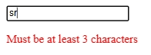
<!DOCTYPE html>
<html>
<body>
<input type="text" id="username" placeholder="Enter username">
<p id="error" style="color:red"></p>
<script>
document.getElementById("username").oninput = function() {
if (this.value.length < 3) {
document.getElementById("error").innerText = "Must be at least 3 characters";
} else {
document.getElementById("error").innerText = "";
}
}
</script>
</body>
</html>

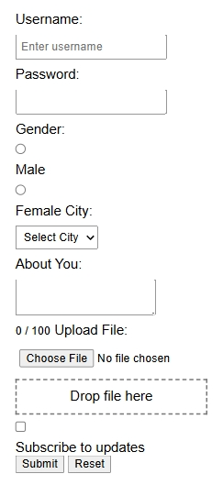
<!DOCTYPE html>
<html>
<head>
<title>Form Properties & Events Demo</title>
<style>
body { font-family: Arial; margin: 20px; }
input, select, textarea { display: block; margin: 8px 0; padding: 5px; }
.drop-area { border: 2px dashed #777; padding: 10px; width: 200px; text-align: center; }
</style>
</head>
<body>
<form id="demoForm" name="loginForm" action="submit.php" method="post" target="_blank"
onsubmit="return handleSubmit(event)" onreset="handleReset()" onforminput="console.log('Input inside form')">

<label>Username:</label>
<input type="text" name="username" id="username" placeholder="Enter username" maxlength="15" required onfocus="msg('Focused Username')" onblur="msg('Blurred Username')">

<label>Password:</label>
<input type="password" name="password" maxlength="10" required onselect="msg('Password text selected')">

<label>Gender:</label>
<input type="radio" name="gender" value="Male"> Male
<input type="radio" name="gender" value="Female"> Female

<label>City:</label>
<select name="city">
<option value="">Select City</option>
<option value="Pune">Pune</option>
<option value="Delhi">Delhi</option>
</select>
<label>About You:</label>
<textarea name="about" maxlength="100" oninput="countChars(this)"></textarea>
<small id="charCount">0 / 100</small>
<label>Upload File:</label>
<input type="file" id="fileInput" name="resume">
<div class="drop-area" ondragover="event.preventDefault()" ondrop="handleDrop(event)" ondragenter="msg('File entered area')" ondragleave="msg('File left area')">
Drop file here
</div>
<label><input type="checkbox" name="subscribe"> Subscribe to updates</label>
<br>
<button type="submit" onmouseover="msg('Hovering submit')" onmouseup="msg('Mouse released')">Submit</button>
<button type="reset">Reset</button>
</form>
<script>
const form = document.forms["loginForm"];
console.log("Form name:", form.name, "Elements:", form.length, "Action:", form.action, "Method:", form.method, "Target:", form.target);
console.log("Username field type:", form.elements["username"].type);
function msg(t){console.log(t);}
function countChars(e){document.getElementById("charCount").innerText=e.value.length+" / 100";}
function handleDrop(e){e.preventDefault();const f=e.dataTransfer.files[0];msg("Dropped: "+f.name);}
function handleSubmit(e){e.preventDefault();if(!form.checkValidity()){form.reportValidity();return false;}alert("Form is valid and submitted!");return true;}
function handleReset(){msg("Form reset!");}
document.getElementById("username").oncopy=()=>msg("Copied!");document.getElementById("username").oncut=()=>msg("Cut!");document.getElementById("username").onpaste=()=>msg("Pasted!");
document.getElementById("password").onkeydown=()=>msg("Key down in password");document.getElementById("password").onkeyup=()=>msg("Key up in password");
form.elements["username"].readOnly=false;form.elements["password"].disabled=false;form.elements["city"].required=true;
</script>
</body>
</html>

